Car Accident

Severity Report

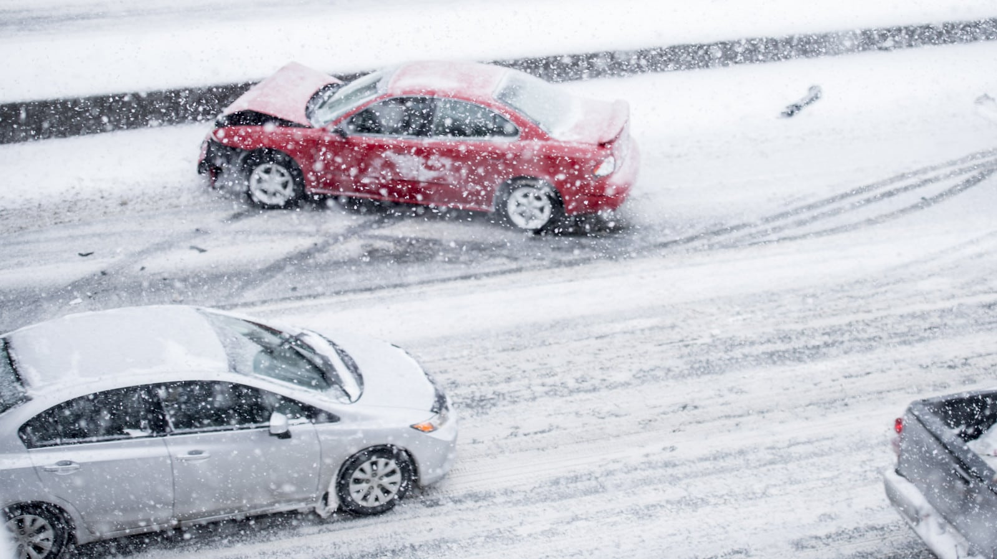

Student: Course:

Rishabh Shinde Applied Data Science Capstone

# Introduction to the Problem

Weather acts through visibility impairments, precipitation, high winds, and temperature extremes to affect driver capabilities, vehicle performance (i.e., traction, stability, and maneuverability), pavement friction, roadway infrastructure, crash risk, traffic flow, and agency productivity. The table below, summarizes the impacts of various weather events on roadways, traffic flow, and operational decisions.

Prediction of future weather conditions has significant impact on social and economic areas of human life. By gathering the weather data, meteorology opens the possibility of analyzing significant patterns in large amounts of data. Over 150 thousand lives annually are claimed due to the climate changes in temperature and precipitation trends

Climate changes also affect traffic flow. By changing external conditions in which transport takes place and which affect the health or concentration of driver’s unfavorable meteorological conditions can lead to traffic accidents, injuries, and death. World Health Organization indicates that the number of road traffic deaths is troublesome and has plateaued at 1.25 million per year.

This study tries to determine the correlation between weather conditions and traffic accident occurrences by analyzing collected data. Data analysis is one of the activities of data science focused on obtaining important information from collected data

# Business Understanding

|  |
| --- |
| To reduce the frequency of car collisions in a community, an algorithm must be developed to predict the severity of an accident given the current weather, road, and visibility conditions. When conditions are bad, this model will alert drivers to remind them to be more careful or possible change travel date, mode, or time, so that it would be safer. |